**Project on Covid Data Analysis using Python**

*Covid-19 is started in Dec 2019 and was first reported from Wuhan, China. It is defined as an illness caused by a novel coronavirus called severe acute respiratory syndrome coronavirus 2(SARS-CoV-2). On march 11,2020, WHO declared Covid-19 a global health emergency.*

**Aim**- The aim of project is to gain insights, make informed decisions, and provide valuable information related to the COVID-19 pandemic. Data analysis can help in various aspects of managing the pandemic, including public health, healthcare resource allocation, policy-making, and public awareness. Analysed COVID-19 data using Python libraries (Pandas, Matplotlib, Seaborn) to unveil insights into infection rates, vaccinations, and mortality trends.

**Steps to be taken in the project:**

Step-1: Importing all the necessary libraries like pandas, numpy, matplotlib, seaborn, datetime

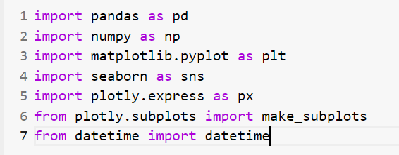

Step-2 : Loading the csv-dataset in variable name “covid_df”

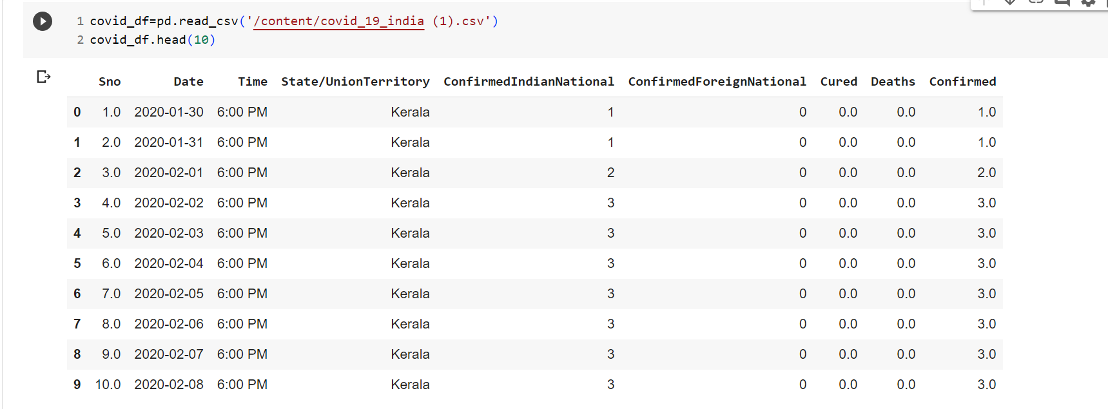

Step-3 : Analysed data using functions like info(),describe()

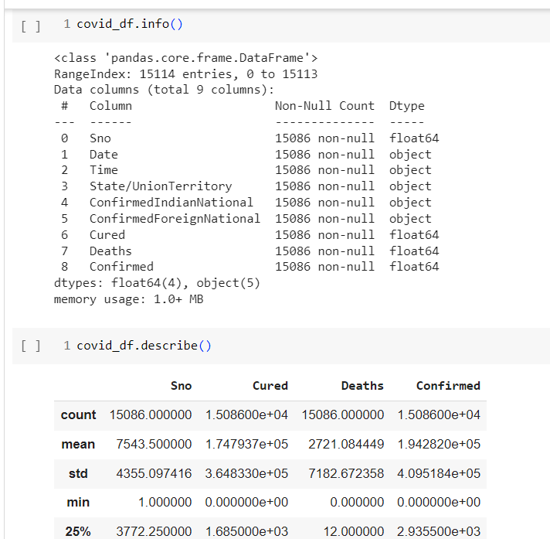

Step-4 : Loading the csv-dataset in variable name “vaccine_df”

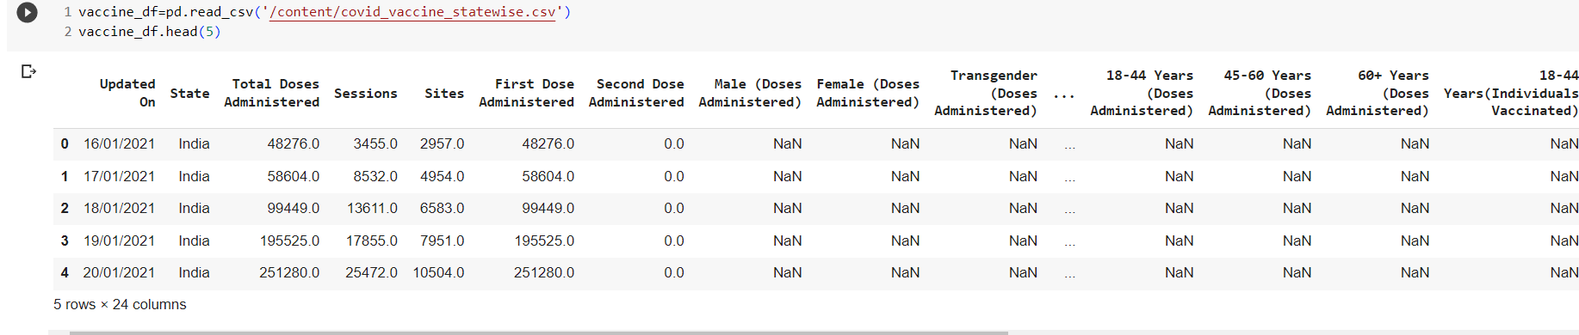

Step-5: Dropping unnecessary columns for better analysis from “covid_df” file

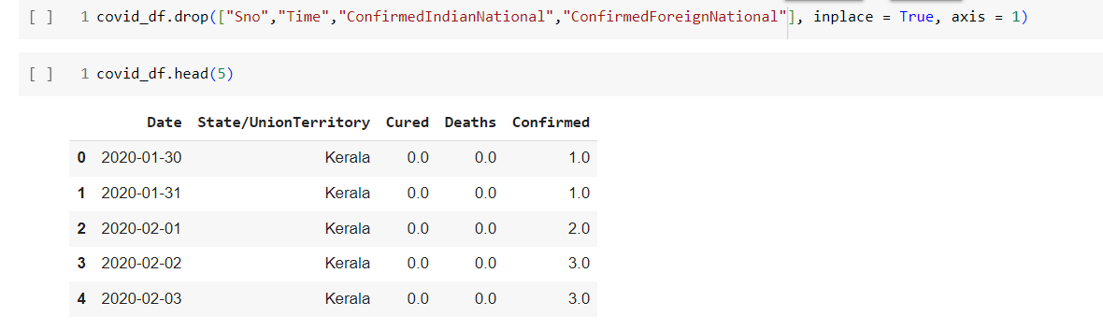

Step-6: Change the format of date column using pandas function datetime

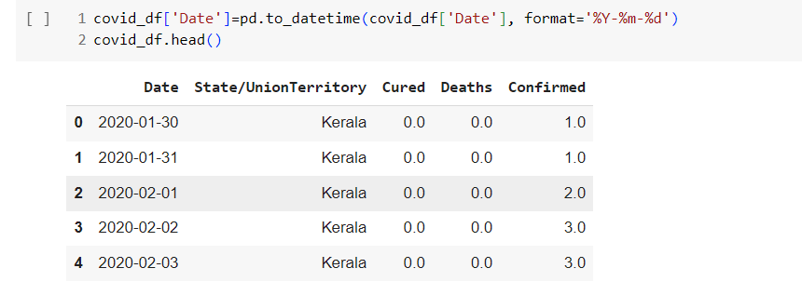

Step-7: Find total number of active cases

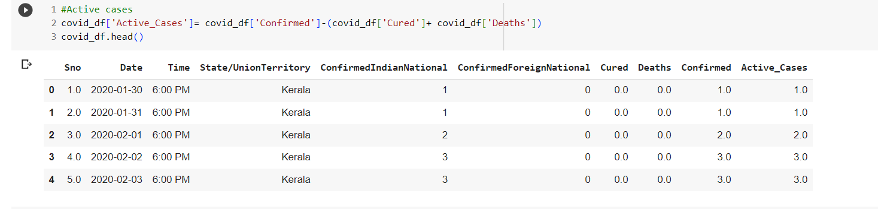

Step-8: Creating pivot table using pandas library, in this table we will summing all the cured, deaths and confirmed cases

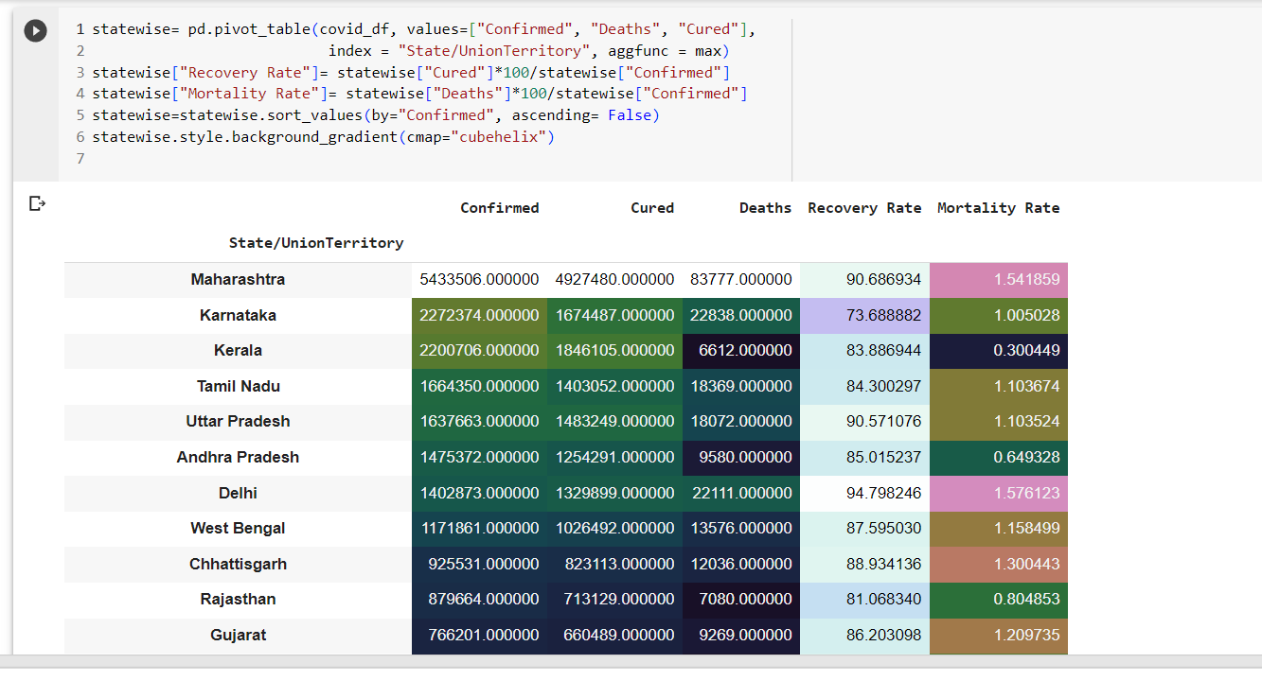

Step-9: Visualizing top 10 states with active cases using bar graph

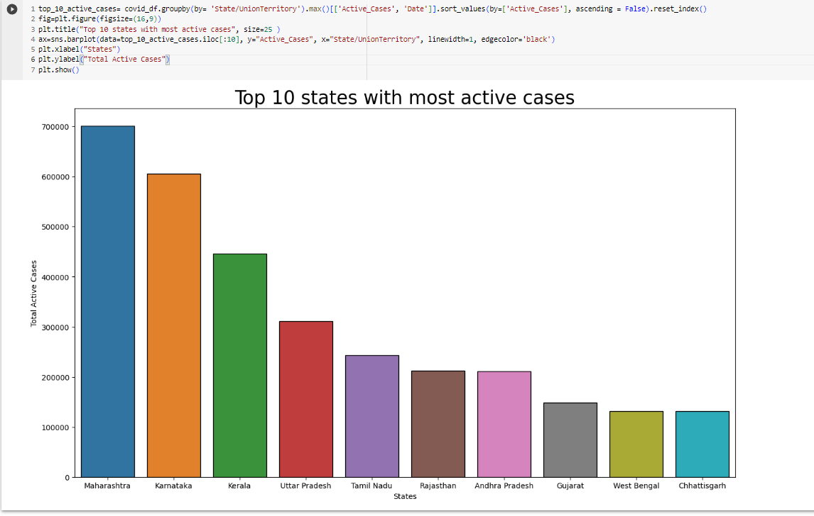

Insights from the graph generated is that, Maharashtra is state with highest number of active cases and Chhattisgarh with the least number of active cases.

Step-10: Visualizing top states with highest deaths using bar graph

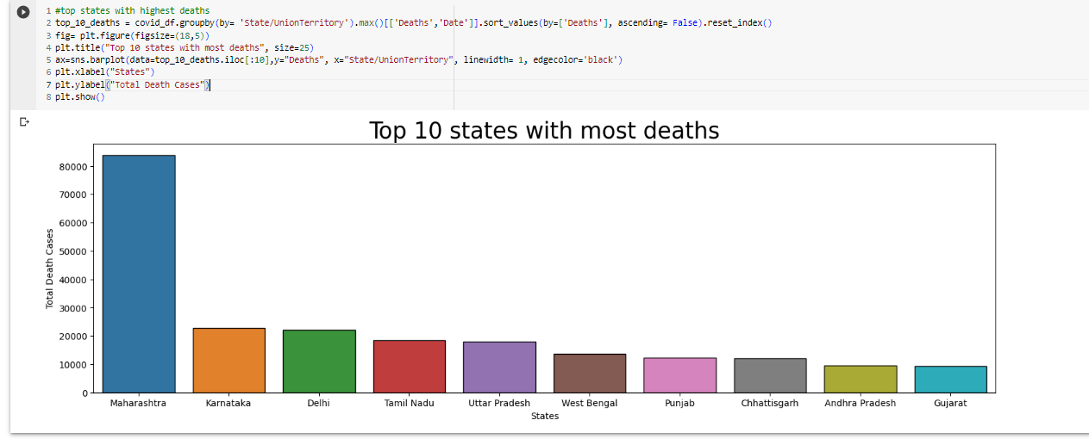

Insights from the graph generated is that, Maharashtra is state with highest number of deaths and Gujarat with the least number of deaths.

Step-11:Visualising growth trend of active cases of top 5 states with most number of confirmed cases using line graph

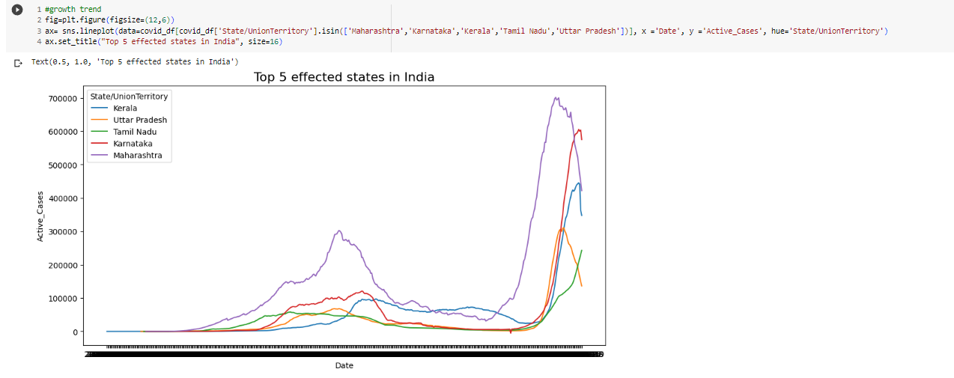

Step-12: Analysed data from” vaccine_df” using functions like info(),describe(),null()

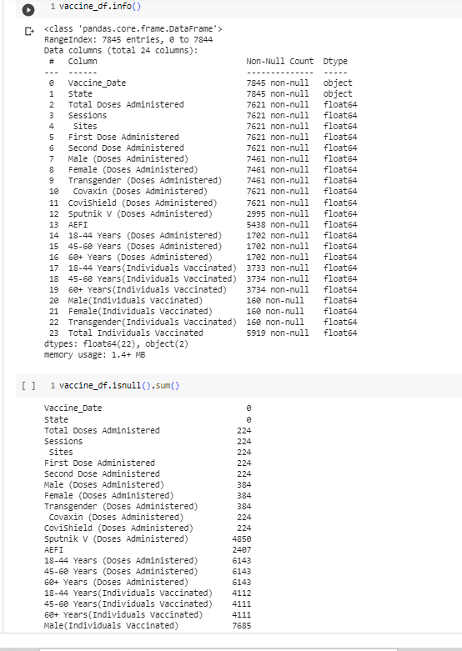

Step-12: Creating pie plot to visualise male vs female vaccination

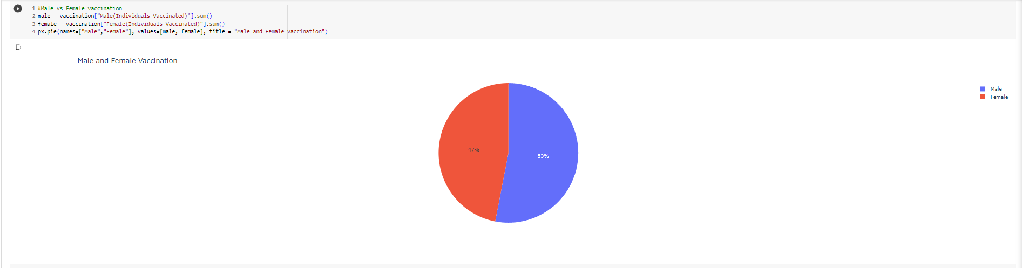

Steo-13: Creating bar graph to visualise most vaccinated state

